WEEK 3 TASK REPORT
Advanced Data Analysis and Visualization in Logistics
Logistics Data Analyst Internship | Hypothetical Dataset | Python EDA
1. Introduction
Logistics performance depends on timely delivery, efficient transportation, and controlled operating costs. This report uses Python to explore a hypothetical shipment dataset through exploratory data analysis (EDA), descriptive statistics, correlation analysis, and visualizations. The dataset is simulated for learning and does not represent a real company.
2. Objectives
Describe the dataset and its key variables.
Calculate central tendency and distribution measures.
Explore relationships among distance, shipment volume, delivery time, and transportation cost.
Create and justify visualizations that reveal logistics trends.
Recommend data-driven actions to improve operational performance.
3. Dataset Simulation and Structure
The dataset contains 240 shipment records and 10 variables. Each row represents one shipment. The fixed random seed (2026) makes the simulation reproducible.

Variable | Description | Type / Unit
shipment_id | Unique shipment identifier | Text
order_date | Order placement date | Date
region | Operating region | Category
transport_mode | Road, Rail, or Air | Category
distance_km | Route distance | Numeric, km
shipment_volume_units | Number of shipped units | Numeric, units
delivery_time_days | Elapsed delivery time | Numeric, days
promised_delivery_days | Promised delivery duration | Numeric, days
transport_cost_inr | Transportation cost | Numeric, INR
on_time_delivery | 1 = on time, 0 = late | Binary
4. Methodology and Data Quality Checks
Pandas was used for data manipulation and summary statistics, NumPy for reproducible data simulation, and Matplotlib for visualization. Checks covered dataset shape, data types, missing cells, duplicate shipment IDs, and negative values in distance and cost.
Results: 240 rows and 10 columns; missing cells = 0; duplicate shipment IDs = 0; negative distance records = 0; negative cost records = 0. In real operational data, these checks should be followed by date validation, category checks, and investigation of suspicious records.
5. Exploratory Data Analysis
5.1 Descriptive statistics and central tendency
Mean is the arithmetic average; median is the middle observation; mode is the most frequent value. Standard deviation measures spread, while minimum and maximum show the observed range.
Metric | Count | Mean | Median | Std. dev. | Min | Max
Distance (km) | 240 | 425.38 | 419.50 | 157.72 | 35.00 | 819.30
Shipment volume (units) | 240 | 249.58 | 248.00 | 145.45 | 14.00 | 500.00
Delivery time (days) | 240 | 3.39 | 3.30 | 1.45 | 0.50 | 7.40
Transport cost (INR) | 240 | 4310.78 | 4036.18 | 1951.03 | 500.00 | 13122.69
5.2 Delivery-time distribution
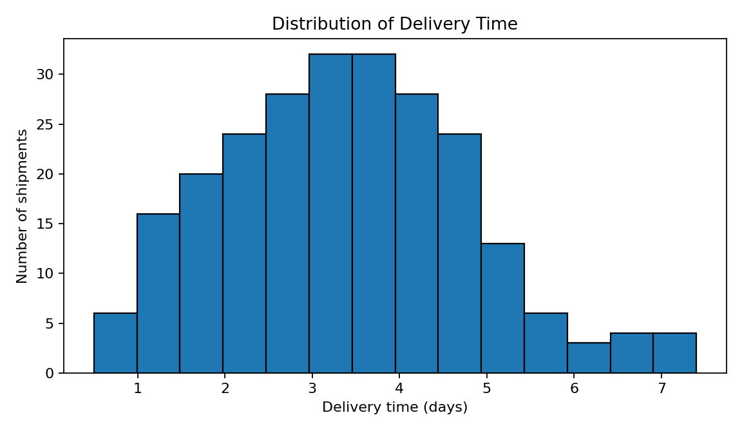
The histogram shows how frequently delivery durations occur across shipments. Mean delivery time is 3.39 days and median delivery time is 3.30 days. The histogram is appropriate because it reveals clustering, spread, and potential skew that a single average cannot show. Slower-tail observations should be reviewed by route and transport mode.
5.3 Distance and transportation cost
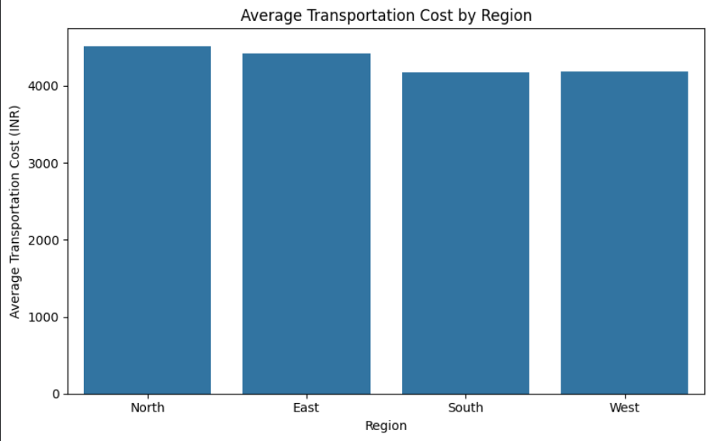
The scatter plot compares distance with total transportation cost; the Pearson correlation is 0.57. A positive relationship suggests that longer routes tend to cost more in this simulated dataset. Scatter plots are useful because they show direction, strength, spread, and unusual points. Distance is not the only cost driver: transport mode and shipment volume also matter.
5.4 Correlation analysis
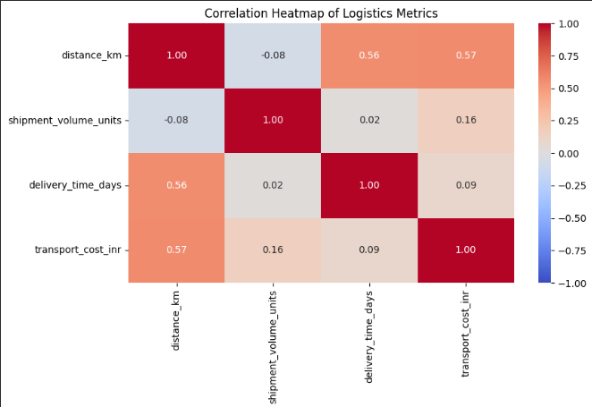
Distance–delivery-time correlation = 0.56; shipment-volume–cost correlation = 0.16. The correlation matrix summarizes linear relationships. Values closer to +1 indicate stronger positive association, values closer to -1 indicate stronger negative association, and values near zero indicate little linear association. Correlation does not establish causation.
5.5 Average delivery time by transport mode
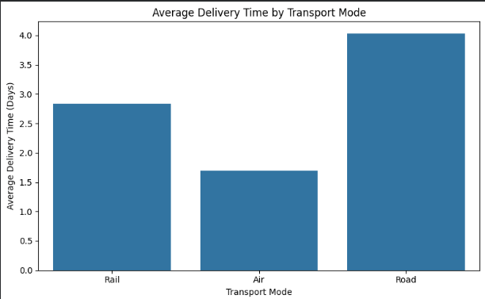
A bar chart compares average delivery time across Road, Rail, and Air. It is suitable for comparing a numeric summary across categories. In the simulation, modes have different assumed transit rates and road shipments include occasional additional delays. In practice, compare service speed, cost, reliability, and shipment urgency together.
6. Transport Mode Summary
Mode | Shipments | Avg days | Median days | Avg cost (INR) | On-time rate
Air | 38 | 1.69 | 1.85 | 7077.26 | 36.8%
Rail | 54 | 2.84 | 3.00 | 2843.77 | 35.2%
Road | 148 | 4.03 | 4.10 | 4135.72 | 29.1%
7. Key Analytical Insights
The simulated on-time delivery rate is 31.7%, providing an illustrative baseline. It depends on the simulated promised-time rule and should not be treated as a real service level.
Average delivery time is 3.39 days and median delivery time is 3.30 days. Comparing mean and median helps assess whether unusually long deliveries may affect the average.
Distance and transportation cost have a correlation of 0.57; distance is a useful cost-planning factor, but it does not explain every cost difference.
Shipment volume and total transportation cost have a correlation of 0.16. Track cost per unit as well as total cost to judge whether larger shipments gain scale efficiency.
Road shipments include simulated extra delays for a subset of records. In a real operation, investigate route congestion, dispatch time, loading wait time, and delivery hand-offs.
Regional differences are signals for further analysis, not proof of inefficiency; compare shipments with similar distance, volume, and transport mode.
8. Recommendations
Track on-time delivery rate weekly by region, transport mode, and route; investigate repeated failures rather than relying only on the overall rate.
Measure total cost, cost per kilometre, and cost per unit together to separate route-length effects from operating inefficiency.
Review delayed road shipments for traffic, dispatch scheduling, loading wait time, and route planning; pilot improvements before scaling.
Report mean, median, and a high percentile such as the 90th percentile to understand both typical and slower delivery experiences.
Compare transport modes on speed, cost, and reliability; the fastest mode may not be the most economical for every shipment.
Validate unique shipment IDs, allowed category values, date consistency, non-negative measures, and units before each reporting cycle.
9. Python Code Excerpt
import pandas as pd
import matplotlib.pyplot as plt
df = pd.read_csv("week3_hypothetical_logistics_dataset.csv")
print(df.shape)
print(df.isna().sum())
metrics = ["distance_km", "shipment_volume_units",
"delivery_time_days", "transport_cost_inr"]
print(df[metrics].describe())
print(df[metrics].corr())
plt.hist(df["delivery_time_days"], bins=14, edgecolor="black")
plt.xlabel("Delivery time (days)")
plt.ylabel("Number of shipments")
plt.title("Distribution of Delivery Time")
plt.tight_layout()
plt.show()
plt.scatter(df["distance_km"], df["transport_cost_inr"], alpha=0.7)
plt.xlabel("Distance (km)")
plt.ylabel("Transportation cost (INR)")
plt.title("Distance vs Transportation Cost")
plt.tight_layout()
plt.show()
The complete notebook is provided separately and generates the dataset, runs the analysis, and creates all visualizations. Run every cell before submission and confirm the output matches this report.
10. Limitations
This dataset is simulated and its patterns may not match a real logistics company. The on-time indicator is illustrative. Correlation describes association, not cause. Real decisions should use validated shipment data, documented cost definitions, and operational context.
11. Conclusion
This analysis demonstrates how Python EDA can convert shipment data into useful logistics indicators. Descriptive statistics establish baselines, histograms reveal delivery-time distribution, scatter plots explore cost relationships, correlation analysis summarizes associations, and bar charts compare transport modes and regions. A practical next step for a real company is to combine these summaries with route-level delay reasons and cost-per-unit measures, then monitor the impact of targeted improvements.

